‘history -c && history -w’ commands are used for clearing the history of commands executed and saving the history of commands in memory to history file respectively.

* history -c: Clears the command history for the current user.
* history -w: Saves the cleared history, ensuring the changes are permanent.
* history: This prints the command history, which should now be **empty** after clearing it

This checks if Python 3.10 is installed on your system. If you see any output indicating Python 3.10 is installed, proceed to uninstall it.

This downloads the tarball file (Python-3.10.0.tgz) from the official Python website.

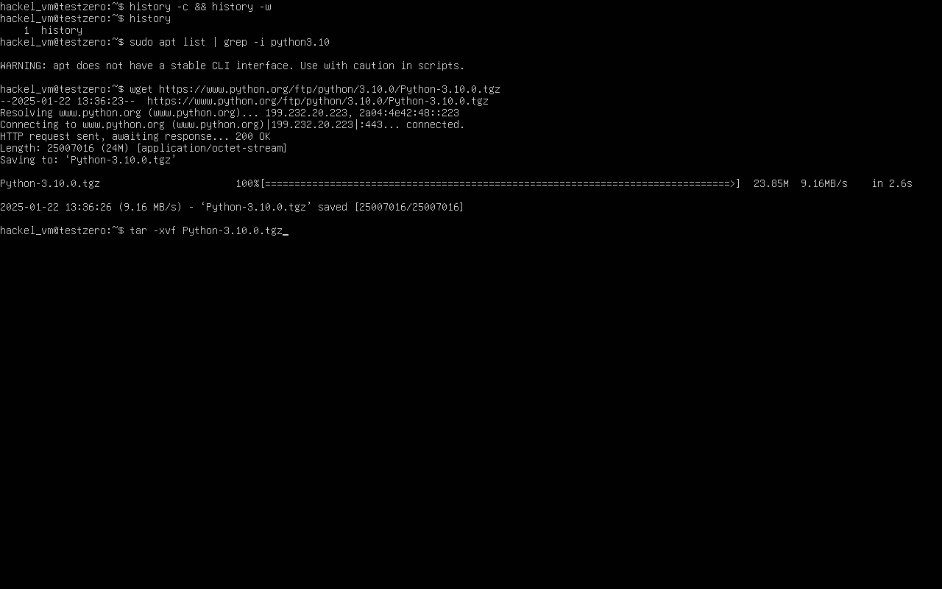

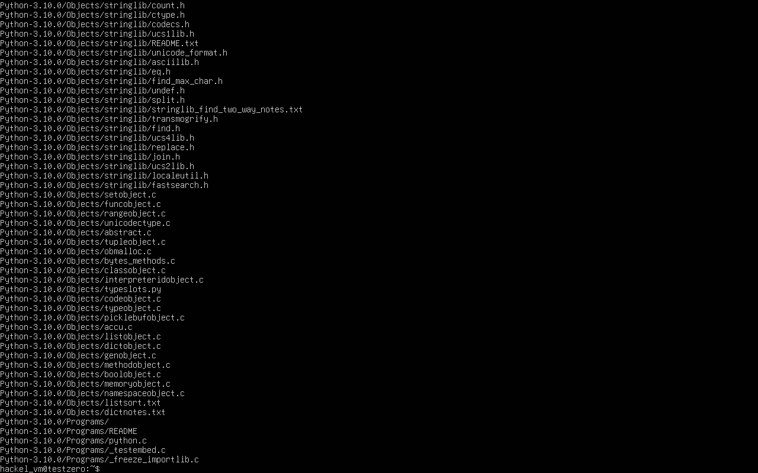

Extracts the tarball file into the working directory

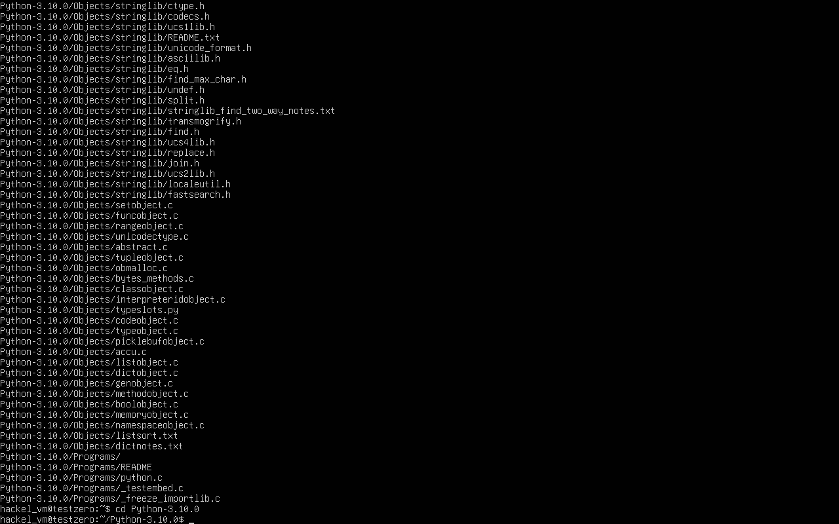

Change to the extracted directory

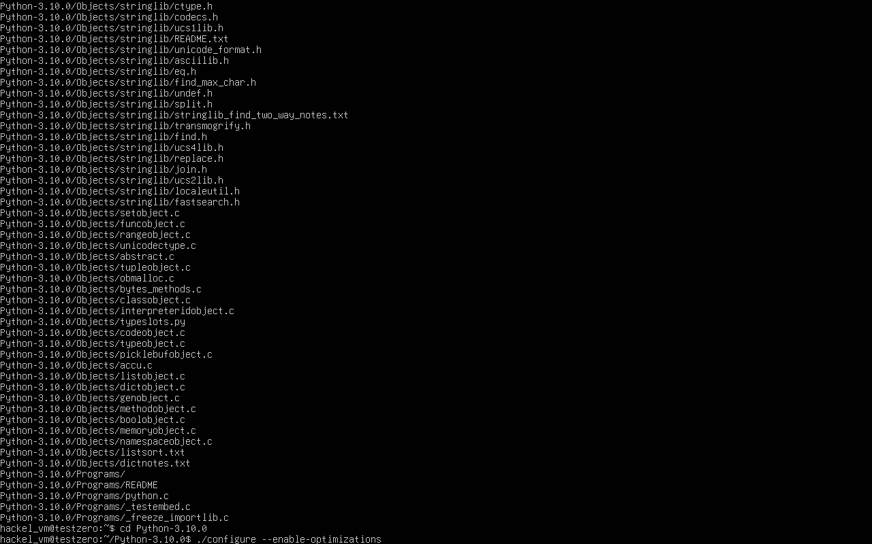

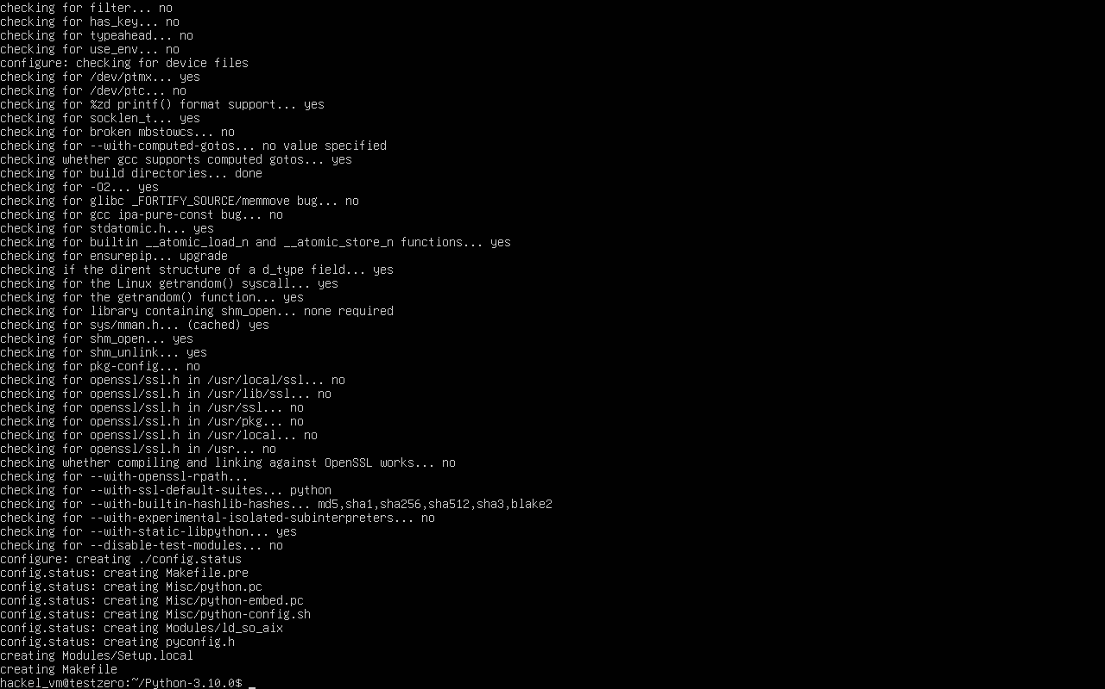

./configure: Prepares the source code for installation. This configures the source code for your system and enables performance optimizations.

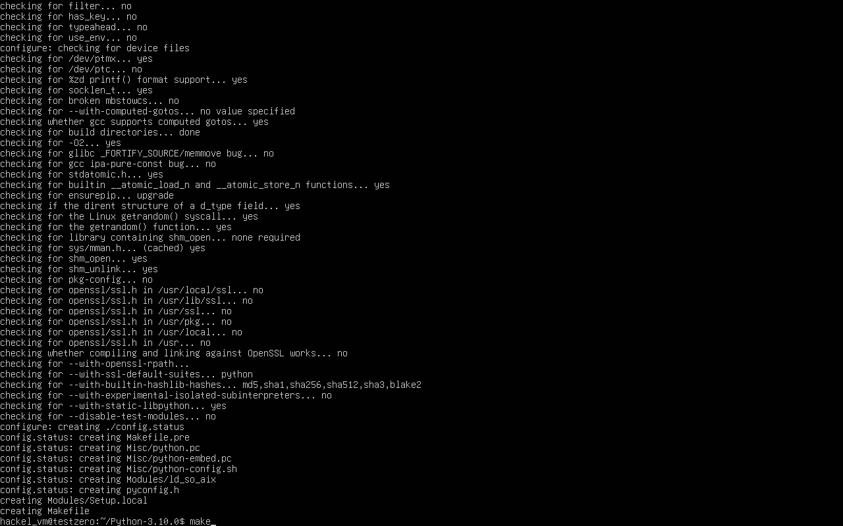

make: Compiles the source code into executable binaries.

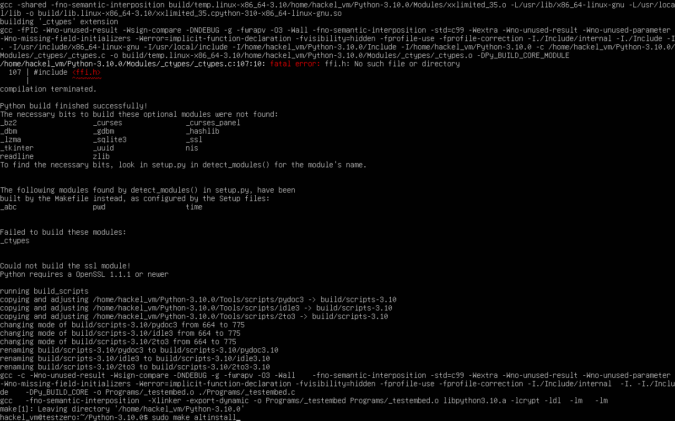

sudo make altinstall: Installs Python without overwriting the default system Python.

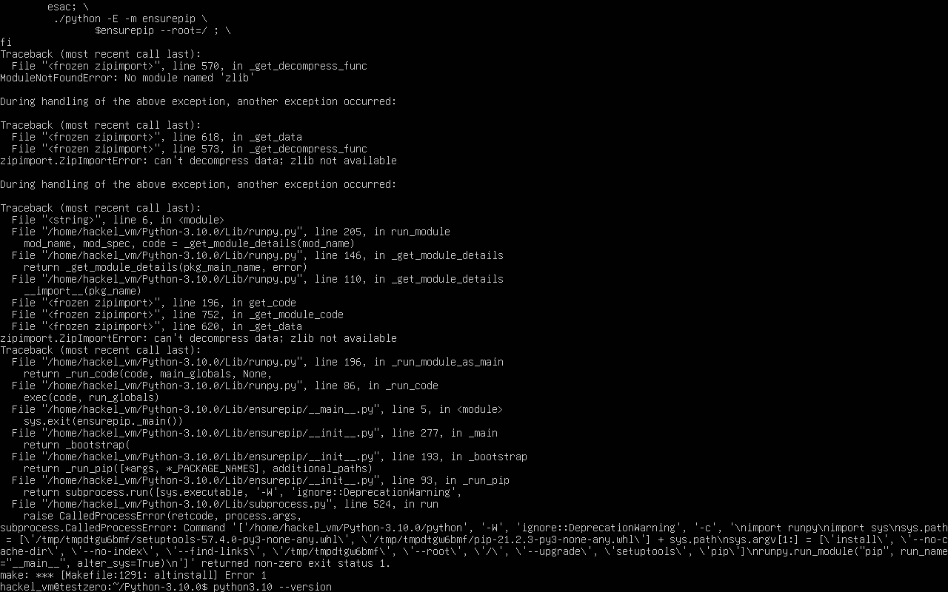

Verify the installation of python3.10

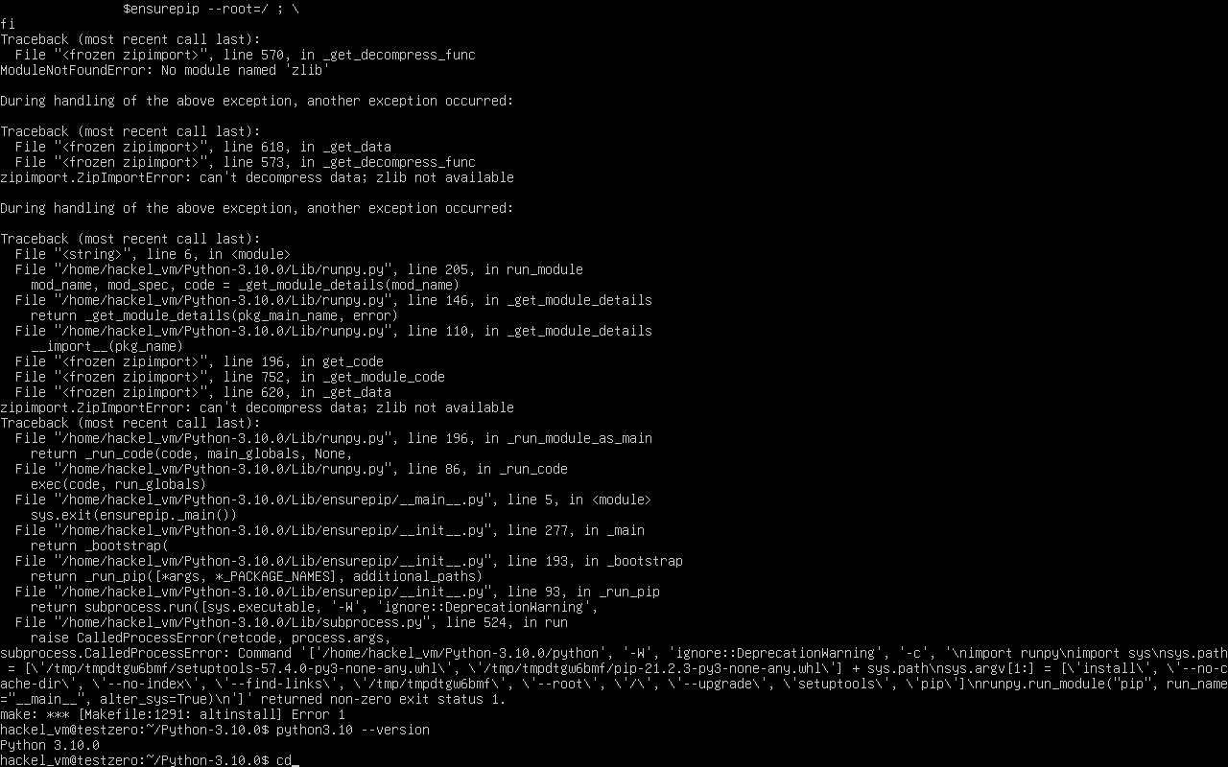

Changing the directory for virtual environment setup

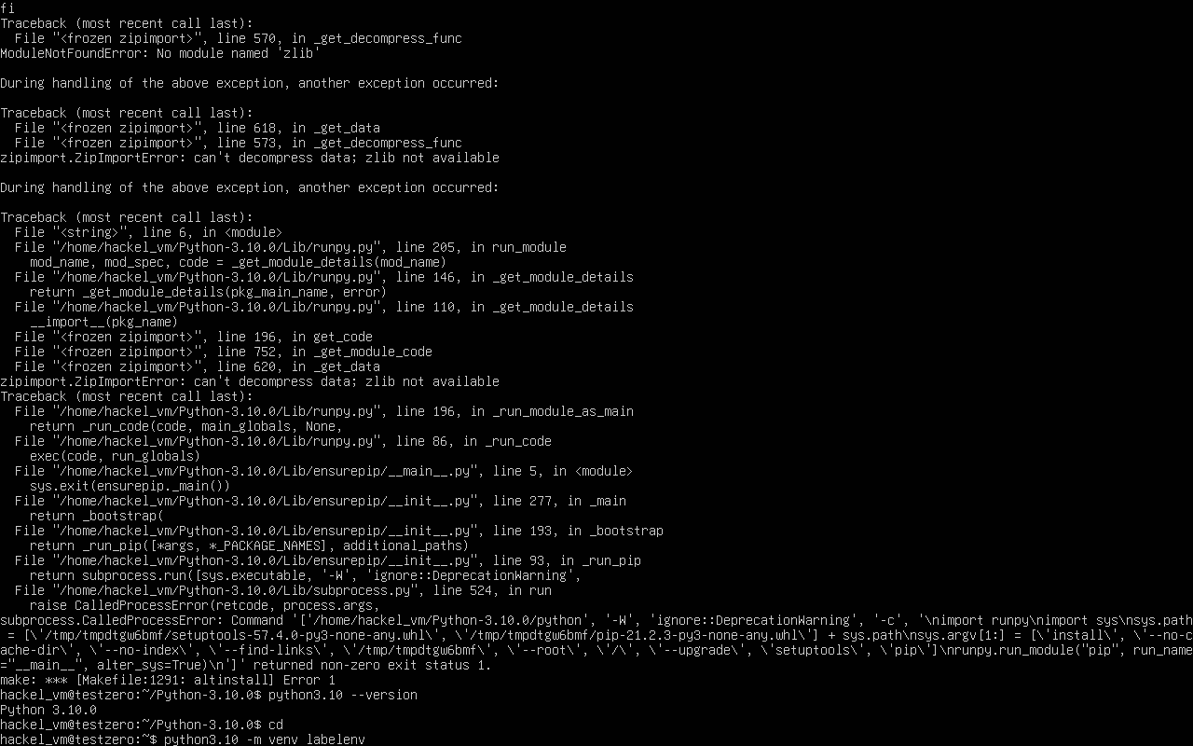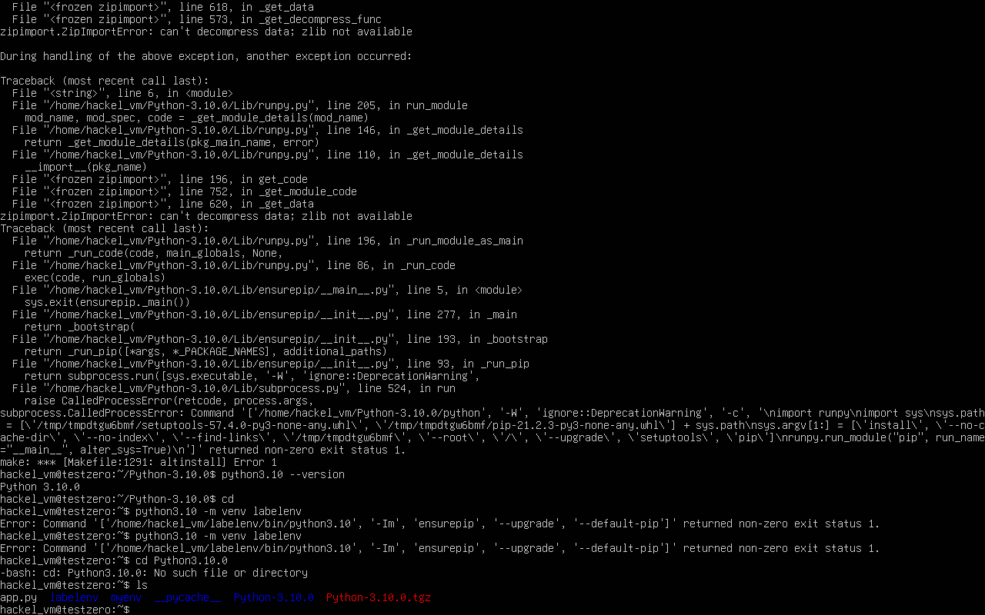

This creates a virtual environment named labelenv using Python 3.10.

